**Chatbot to shop for essentials during pandemic using Watson Assistant**

**Introduction:**

“Digitalisation, the surge of mobile and internet connected devices has revolutionised the way people interact with one another and communicate with businesses.

The banking and the financial service industry was one of the first industries to adopt technology. This integration has grown massively, helping banks reach a wider customer base enabling them to perform their banking conveniently.

Banks are now enabling the use of technology so customers can perform more tasks online, such as; cheque image clearing to allow the payment of cheques remotely and intelligent chatbots to increase customer service and assist employees.

Banks are now enabling the use of technology so customers can perform more tasks online, such as; cheque image clearing to allow the payment of cheques remotely and intelligent chatbots to increase customer service and assist employees.

Chatbots, like regular applications, have application layers, databases, conversational user interfaces (CUIs) and APIs.

There are 3 common kinds of a chatbot available today:

**Rule-based chatbots:** The most straightforward option, these bots simply provide a pre-defined answer to very specific questions. These bots are great for things like qualifying leads or offering customers an interactive FAQ experience

**Intelligent chatbots:** These intelligent bots use machine learning or “ML” to learn from the user’s requests and information. Intellectual bots are trained to understand specific words and phrases that trigger a reply. They teach themselves over time to understand more questions and deliver better answers

**AI-powered chatbots:** These bots combine the benefits of rule-based bots with the power of intellectually independent programs to solve user problems. They can remember the context of conversations and understand user preferences. These bots use a combination of natural language processing, machine learning, and AI to understand customers. Natural language processing helps the interactions between humans and computers to feel more natural

**Purpose**

Today, because of social distancing and other issues it can be risky for some people to shop for essential items in person. This project helps with this issue by giving people an online option to shop for essentials. With the help of Watson assistant, a chatbot is built. This chat has the following capabilities:

1. Give the list of items in the Store
2. Show the prices of vegetables
3. Display if there are any offers or discounts

**How Chatbots Work?**

There are 3 fundamental classification methods used to run a chatbot.

The first option is to create a pattern-matching bot. These bots classify text and produce a response based on the keywords they see. A standard structure for these patterns is AIML (Artificial Intelligence Mark-up Language). In pattern-matching, the chatbot only knows answers to questions that exist in their models. The bot cannot go beyond the patterns already implemented into its system.

Another option for today’s chatbots is to use algorithms. For each kind of question, a unique pattern needs to be available in a database for the bot to provide the right response. With various combinations of trends, it is possible to create a hierarchical structure. Algorithms are how developers reduce the classifiers and make the structure more manageable. The classic algorithm for NLP and text classification is Multinational Naïve Bayes.

The final crucial methodology for chatbots is to use artificial neural networks. These are solutions that give the bots a way to calculate the response to a question using weighted connections and context in data. With artificial neural networks, each sentence provided to a bot is broken down into different words, and each word is used as an input for the neural network. Over time, the neural network becomes stronger and more advanced, helping the bot to create a more accurate set of responses to common queries.

There are many different types of variations in neural networks. Often, businesses that use these tools will need to train their bots over time to become more efficient and effective. Fortunately, training for a chatbot happens at a much larger and faster scale than teaching for a human. A customer support chatbot, for instance, can be fed thousands of conversation logs, and use the information from those logs to support its neural network.

What is more, when a chatbot is ready to interact with live customers, businesses can implement smart feedback loops. This means that during a conversation, when customers ask a question, a chatbot can deliver a couple of intelligent answers with options like “Did you mean a, b, or c”. The way the customer respond will help to reinforce the bot’s understanding and train the machine learning model.

**AI-powered chatbot:**

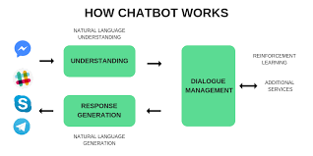

**NLU (NATURAL LANGUAGE UNDERSTANDING)**

It has 3 specific concepts like:

**Entities**: Entity basically represents a concept in your Chatbot. It might be a payment system in your Ecommerce Chatbot.

**Intents**: It is basically the action chatbot should perform when the user say something. For instance, intent can trigger same thing if user types “I want to order a red pair of shoes”, “Do you have red shoes? I want to order them” or “Show me some red pair of shoes”, all of these user’s text show trigger single command giving users options for Red pair of shoes.

**Context**: When a NLU algorithm analyzes a sentence, it does not have the history of the user conversation. It means that if it receives the answer to a question it has just asked, it will not remember the question. For differentiating the phases during the chat conversation, it’s state should be stored. It can either be flags like “Ordering Pizza” or parameters like “Restaurant: ‘Dominos’”. With context, you can easily relate intents with no need to know what was the previous question.

**NLP (NATURAL LANGUAGE PROCESSING)**

[Natural Language processing (NLP)](https://marutitech.com/how-is-natural-language-processing-applied-in-business/) Chatbot takes some combination of steps to convert the customer’s text or speech into structured data that is used to select the related answer. Some of the Natural Language Processing steps are:

**Sentiment Analysis**: Tries to learn if the user is having a good experience or if the after some point the chat should be forwarded to the human.

**Tokenization:** The NLP divides a string of words into pieces or tokens that are linguistically symbolic or are differently useful for the application.

**Named Entity Recognition**: The chatbot program model looks for categories of words, like the name of the product, the user’s name or address, whichever data is required.

**Normalization**: The Chatbot program model processes the text in an effort to find common spelling mistakes or typographical errors that might the user intent to convey. This gives more human like effect of the Chatbot to the users.

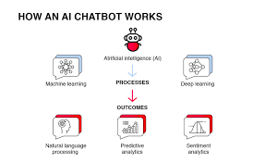

**CHAT BOT using IBM Watson Assistant:**

**Chatbot to shop for essentials during pandemic using Watson Assistant:**

**Services Used:**

1. IBM Watson Assistant
2. Node-Red

**Architecture:**

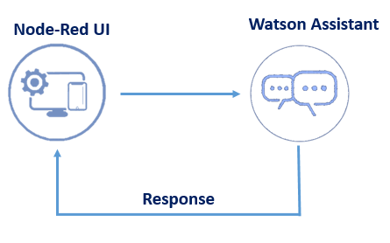

**The procedure using IBM Watson Assistant**

**There are 3 steps to create**

1. **Creating Intents:** Intents are the objectives of every bot. A chatbot that answers questions about you has the broad objective of providing information about a human being. Therefore, it helps to think of this information as it pertains to where, what, and when. In other words, the intents would answer “where did you x”, “what is your y” and “when did you z”. The actual intents would simply be “where”, “what”, and “when” (or location, general info, and time). I have created intents shown below-



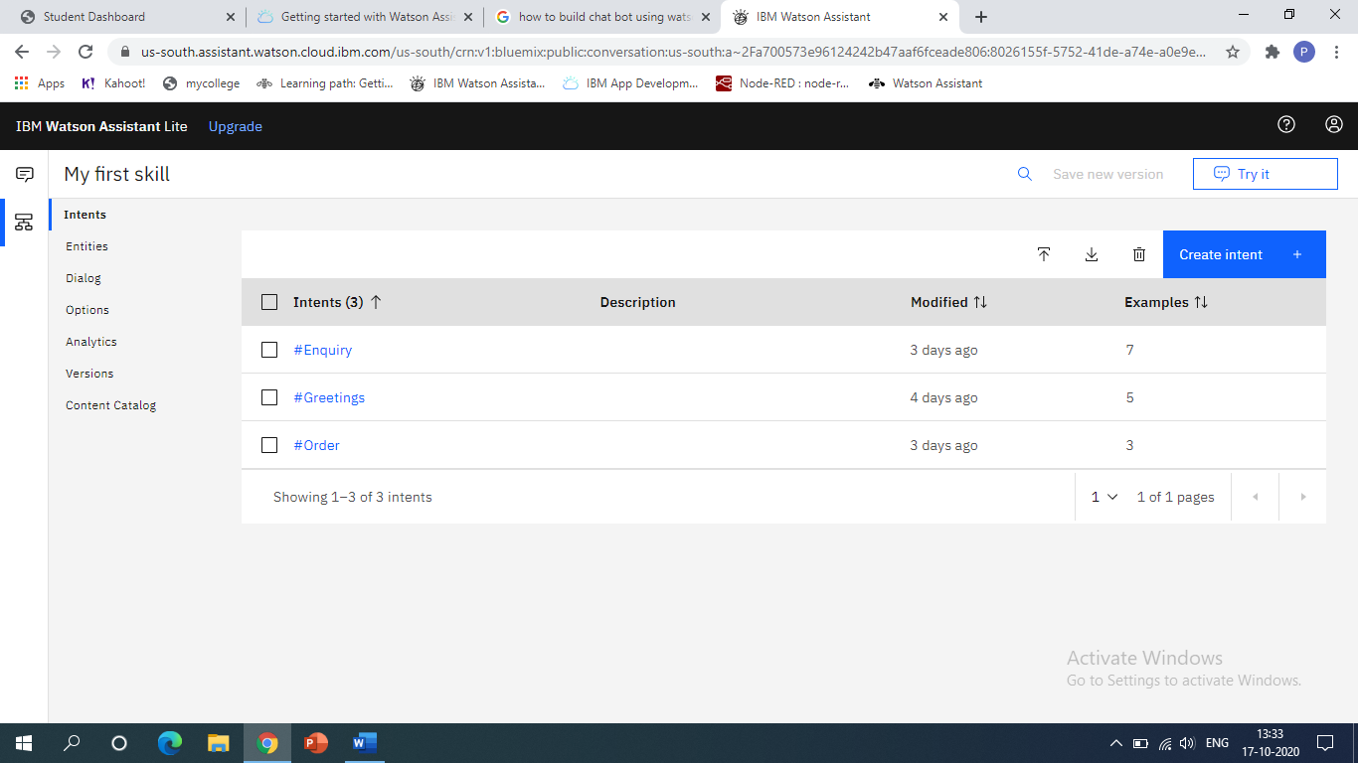

1. **Define Entities:** This allows single entities to apply to multiple intents. In this example “college” could apply to both the “where” and “when” intents. Under each entity, you will also want to add values. Values are sub-subjects of entities. For the above chatbot entities created are shown below-

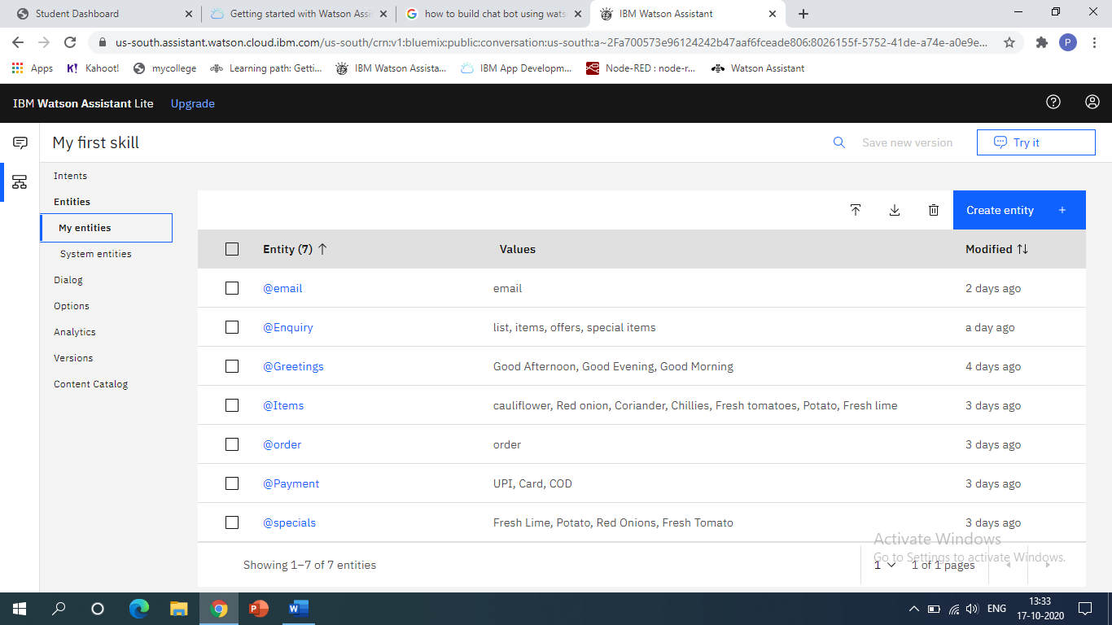

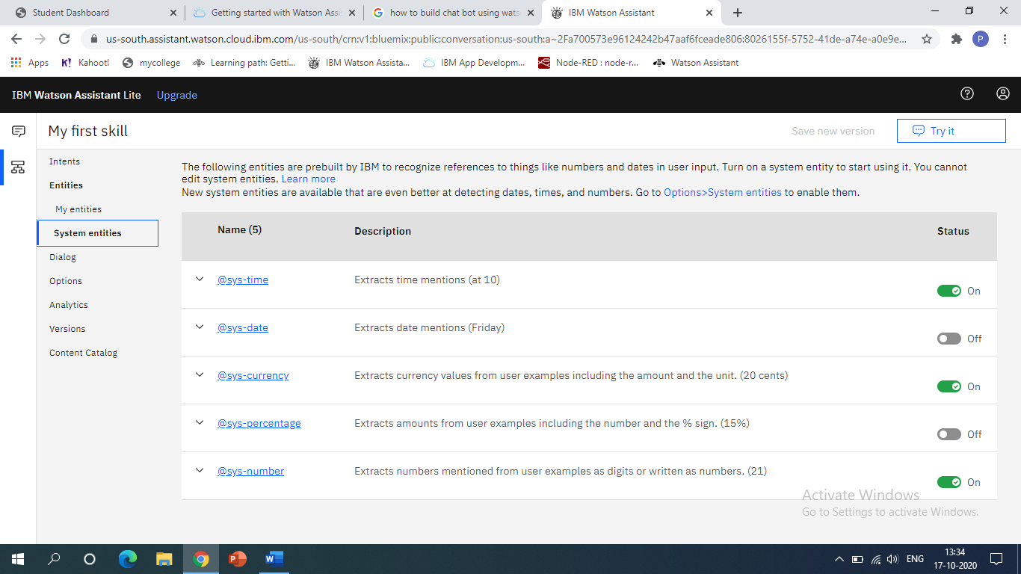

1. **Creating Dialog:** Setting up your dialog flow is all about logic. The dialog in the Conversation API is set up like a logic tree with many “if then” conditions. Each intent begins a node on the left and the logic flows from the top down through your intents. If a certain intent is triggered by an utterance, its node is opened, and the logic continues to entities. The logic within each node (i.e. through entities) also flows from top to bottom. A specific combination of #Intent and @Entity:value triggers a certain response to a question – this combination is referred to as the response condition. So, for “what was your major” the “what” intent would be triggered and then the response associated with the response condition #what and @college:major would be returned. The dialog tree for above chatbot is shown below-

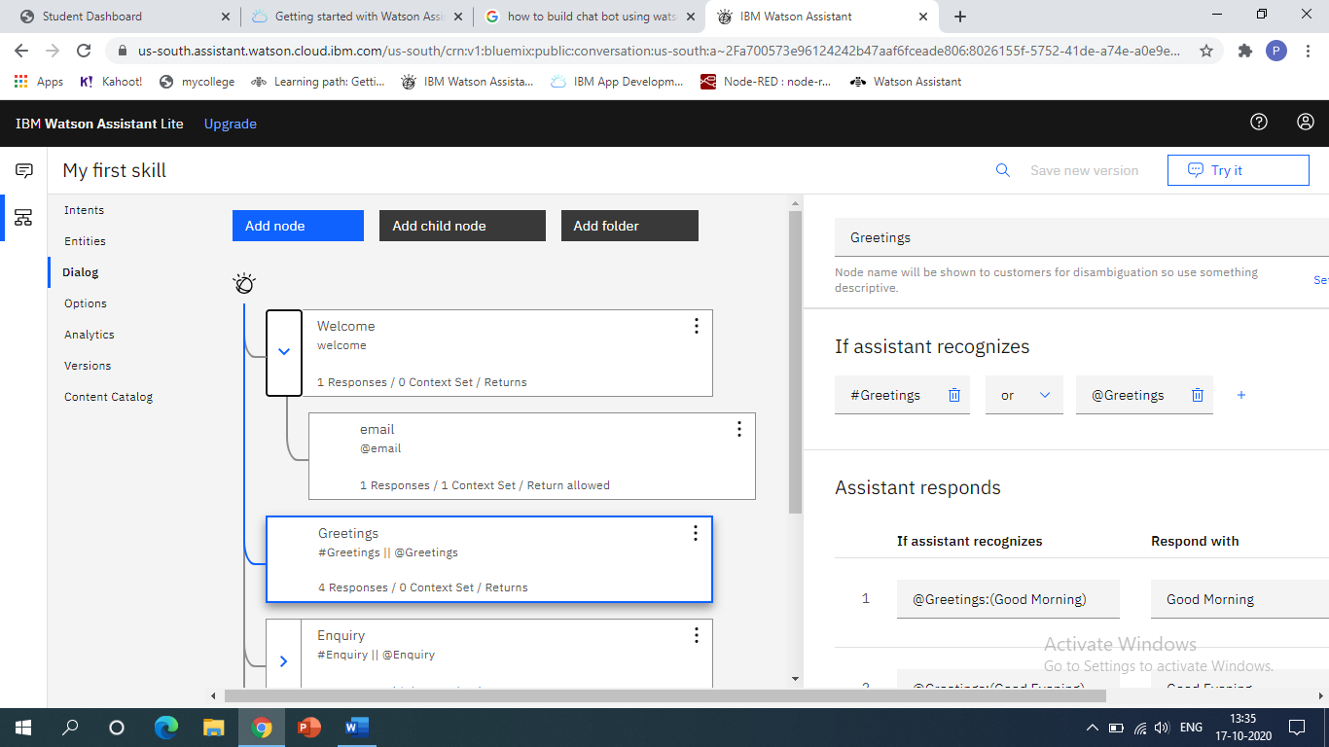

**Integrate Chatbot with Node Red**

1. Open the Node-RED flow created earlier
2. Add another flow with the following connection sequence of nodes and connect the output of the node to the input of the next node. Following nodes are created in Node Red-
3. Inject
4. Debug
5. Complete
6. Catch
7. Status
8. Link in
9. Link out
10. Function
11. Switch
12. Change

**Output with Node Red integration:**

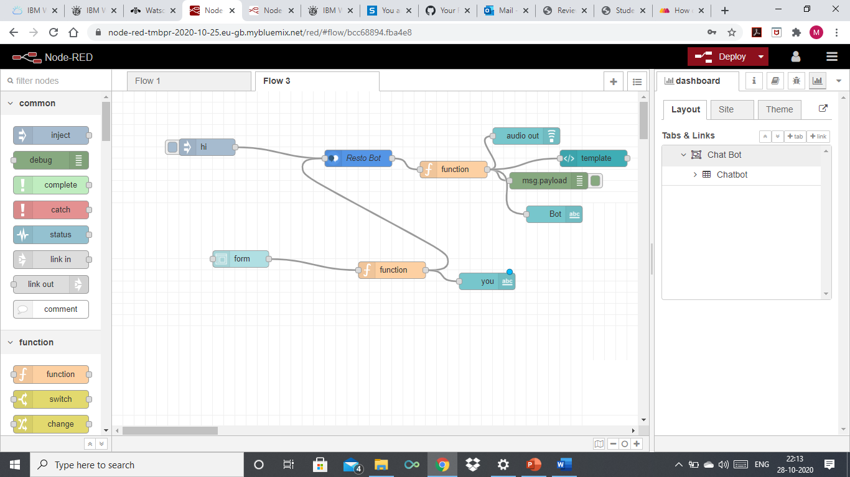

**Results** 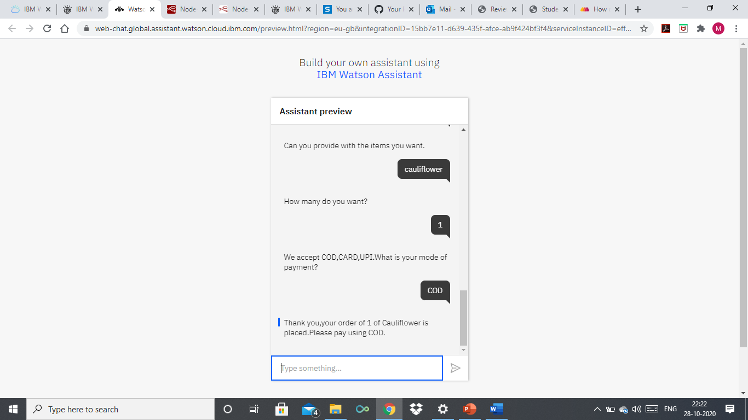

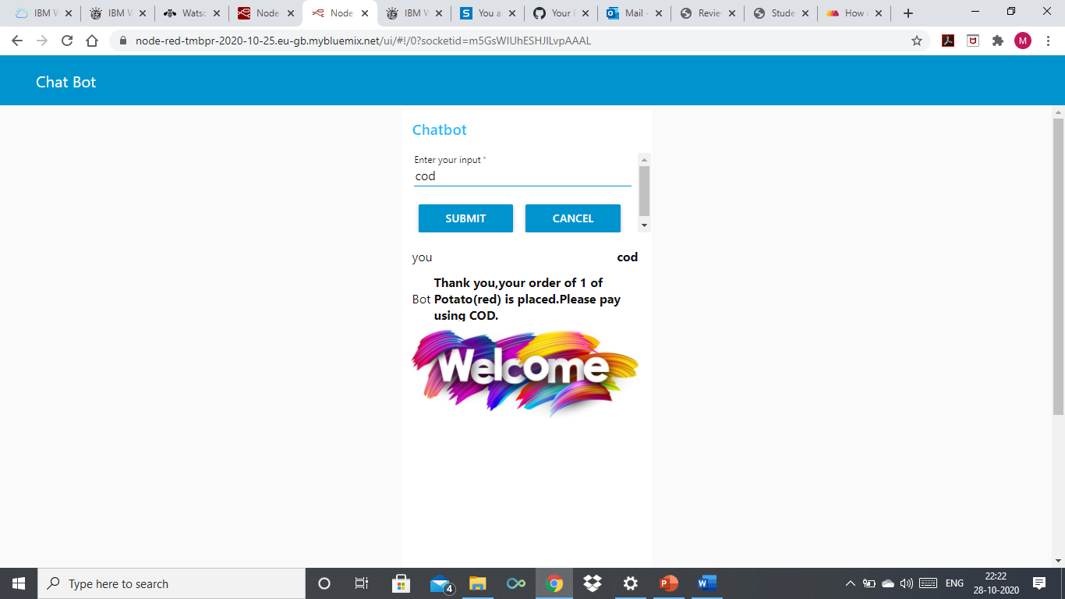

**Conclusion:**

The above designed CHATBOT can greet, show the item list, Show price list, take orders from the customer.